Sphere – ASU DISC Project

The development site is currently setup as a hosted application on Sphere’s ISP account at 1and1.com. This is a ‘one-click’ install that quickly provides a base WordPress install without having to separately setup and configure a MySQL database, PHP or anything else:

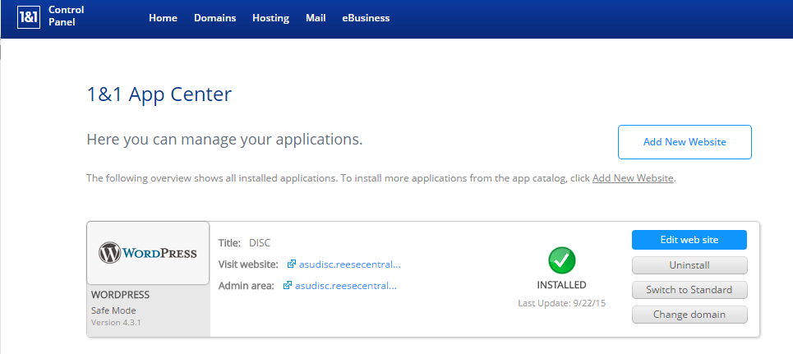

This can be easily duplicated at another ISP, or installed locally or remote by following the standard WordPress Famous 5-minute install directions:

<https://codex.wordpress.org/Installing_WordPress>

Currently the site is running WordPress v4.3.1. A newer version may be available, and should be installed.

Currently the site is running PHP v5.4.44. This is controlled and updated by the ISP, although on a private server you may have other versions available to install. Newer versions may be available, and should be installed. Please see the installation instructions at <http://www.php.net/> .

Currently the site is running MySQL v5.5. This is controlled and updated by the ISP, although on a private server you may have other versions available to install. Newer versions may be available, and should be installed. Please see the installation instructions at https://www.mysql.com/.

Next, a number of plugins should be installed, or verified that they are installed, by using the WordPress built-in Plugin installer:

* Akismet – (v3.1.3, by Automatic) Anti-SPAM
* CIMY Extra User Fields – (v2.6.5, by Marco Cimmino) Database Extension
* Custom Facebook Feed – (v2.3.7, by Smash Balloon) Facebook Extension
* Custom Login Page Customizer – (v1.0.5, by Hardeep Asrani)
* Custom User Registration Form Builder – (v1.4.2, by CMSHelpLive)
* Google XML SiteMaps – (v4.0.8, by Arne Brachhold) For SEO
* JetPack by WordPress – (v3.7, by Automatic) WordPress Extension
* Limit Login Attempts – (v1.7.1, by Johan Eenfeldt) Security
* Photo Gallery – (v1.2.60, by WebDorado)
* ProfilePress Lite – (v1.1.2, by Agbonghama Colins)
* Shortcake (Shortcode UI) – (v0.5.0, by Fusion Engineering)
* Simplr User Registration Form Plus – (v2.3.7, by Mike Van Winkle)
* The Events Calendar – (v3.12.1, by Modern tribe)
* Theme My Login – (v6.3.12, by Jeff Farthing)
* Yoast SEO – (v2.3.4, by Team Yoast) SEO

All of these plugins are available through the built-in WordPress Plugin installer. Please note that versions shown are the minimum versions that should be installed; newer versions may be available and should be installed.

The final step would be to use the WordPress Import function to import the configuration of the site. On the WordPress dashboard, select Tools, the Import:

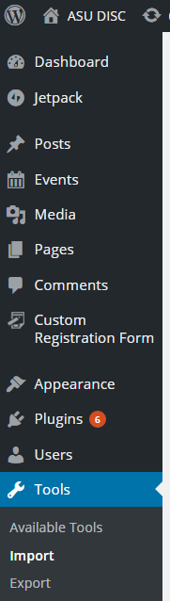

Once the import is complete, you should have a functional WordPress site.